The Battle of Neighborhoods

Chenjian SHI

June 27, 2020

**1. Introduction**

**1.1 Background**

New York is a prominent location for the American entertainment industry, with many films, television series, books, and other media being set there. As of 2012, New York City was the second largest center for filmmaking and television production in the United States, producing about 200 feature films annually, employing 130,000 individuals; the filmed entertainment industry has been growing in New York, contributing nearly US$9 billion to the New York City economy alone as of 2015, and by volume, New York is the world leader in independent film production– one-third of all American independent films are produced in New York City. The Association of Independent Commercial Producers is also based in New York. In the first five months of 2014 alone, location filming for television pilots in New York City exceeded the record production levels for all of 2013, with New York surpassing Los Angeles as the top North American city for the same distinction during the 2013/2014 cycle. International film makers are featured prominently in New York City as well.

As the figures tell, New York City attracts many to start their business in entertainment industry. Before they take action, they need to find out where they would open it? What would they consider when selecting a location? By exploring the regional characteristics of these entertainment faucility, I hope to figure out whether the neighborhood of cinema is an essential factor for the success of a cinema with sound analysis.

**1.2 Interest**

As I mentioned above, there are hundreds of cinema, and it is impractical to run an analysis for each type of cinema. Based on the maximum total numbers among these cinema, I choose Manhattan for the following report. The study of other types of cinema can be conducted with the same method.

**2. Methodology**

And I used **Geopy** to get the geological location of each community board.

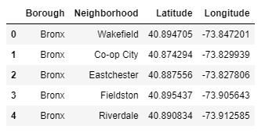

I utilized the **Foursquare API** to explore the boroughs and segment them. I designed the limit as 100 venues and the radius 500 meters for each borough from their given latitude and longitude information. Here is the header of the result, adding venue id, venue name, category, latitude, and longitude information from Foursquare API.

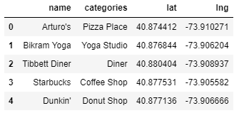

I utilized the **Foursquare API**again by pizza places ID to explore the detailed record of these places.

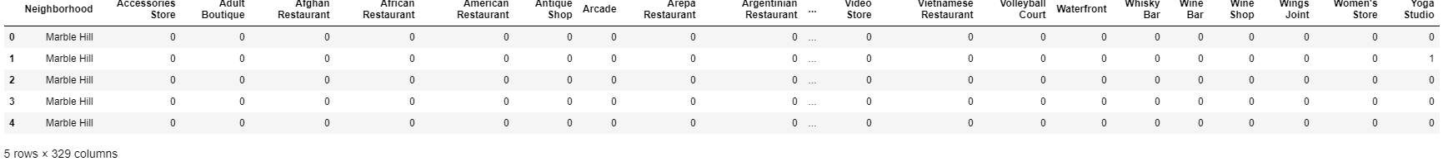

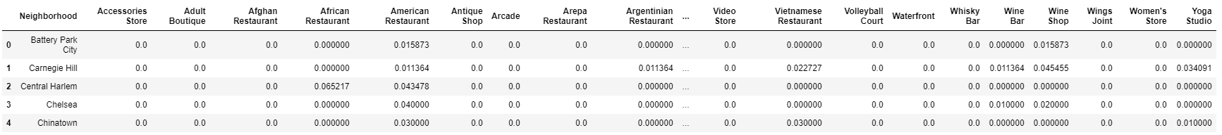

Showing from the correlation matrix, Likes, Photos, and Tips are highly correlated with each other. But Likes is not highly related to Rating. Customers who click Likes for some specific reasons but give lower ratings to the general performance might cause this low correlation. Therefore I choose Rating to represent the movie theater.

I utilized the **Foursquare API**centering these movie theater to explore their neighborhoods with a 500-meter radius.

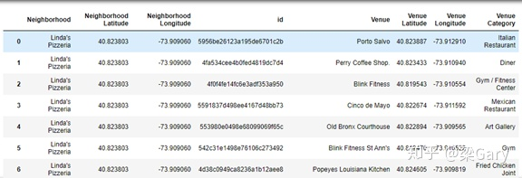

Then I used **folium** to visualize the distribution of these pizza places in NYC as below:

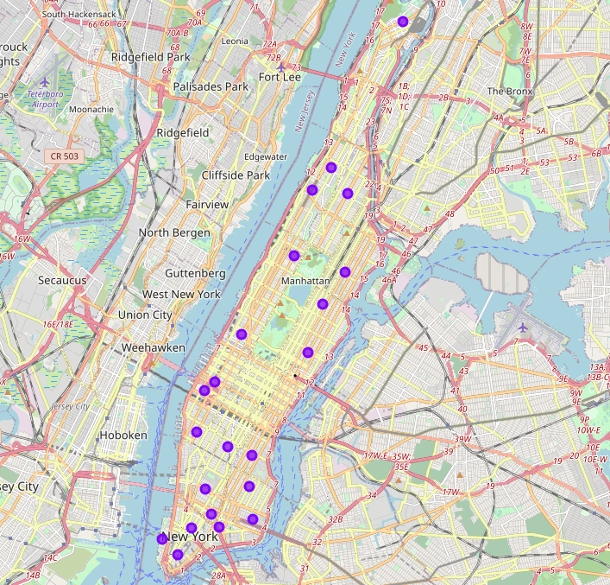

**3. Conclusion**

As a result, for those types of movie theater place which provide quick services and moderate flavor with moderate price, they should consider locations in a busy area.

**4. Discussion**

The problem of these model is that the information is too less that , the model maybe not so correct, it needs more data for correcting the model

**E. Reference**

[1] New York City—Wikipedia, [https://en.wikipedia.org/wiki/New_York_City](https://link.zhihu.com/?target=https%3A//en.wikipedia.org/wiki/New_York_City)

[2] Neighborhoods in New York City — Wikipedia [https://en.wikipedia.org/wiki/N](https://link.zhihu.com/?target=https%3A//en.wikipedia.org/wiki/Neighborhoods_in_New_York_City)